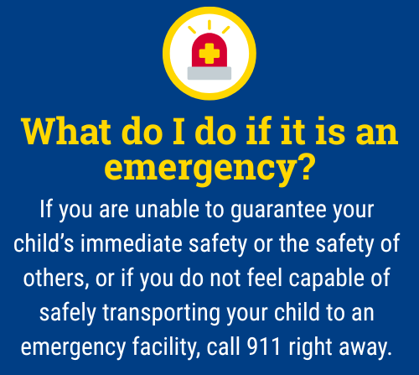

A Guide for Caregivers: Limiting Access to Firearms
When a child is experiencing thoughts of harming themselves or others, it can be one of the most frightening and overwhelming times for a parent. During these critical moments, supervision and monitoring are not just protective, they're powerful tools for understanding, connection, and prevention. This guide outlines action steps you can consider to help keep your child safe while maintaining trust and open communication.

Did you know?
- Firearms are the leading method of death by suicide among youth in Virginia. They are also involved in many tragic incidents of violence.
- Most youth suicide attempts are impulsive. Easy access to a firearm during a crisis can turn a temporary feeling into a permanent tragedy.
- Firearms are extremely lethal. Nine out of ten suicide attempts with a gun result in death.
- Safe storage saves lives. Storing guns unloaded, locked, and separated from ammunition greatly reduces the risk of both suicide and accidental shootings.
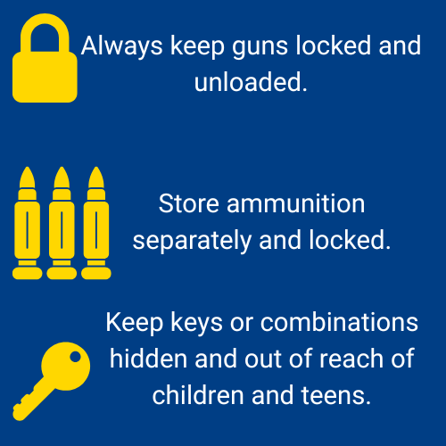

How can I store firearms safely?
Safe storage is a simple, powerful step every parent can take to protect their children and others.
- Always keep guns locked and unloaded.
- Use a gun safe, lockbox, or trigger lock. Never store firearms in easily accessible places, like drawers or closets.
- Store ammunition separately and locked.
- Keep keys or combinations hidden and out of reach of children and teens.

What steps can I take to protect my child from firearm-related risks?
- Talk to all household members about firearm safety and expectations. Ensure guests or relatives who visit also follow safe storage practices.
- Ask about firearms in other homes. Before your child visits a friend or relative, ask if there are firearms in the home and how they’re stored.
- If your child is experiencing mental health challenges, remove access to firearms immediately. Consider removing firearms from the home temporarily or storing them off-site.
- Visit the Lock and Talk website and scroll to the bottom of the page for the interactive map to find your local Community Services Board (input your zip code) to access free firearm locks or medication lock boxes.

In Virginia, what legal requirements exist relating to the safe storage of firearms in the presence of minors?

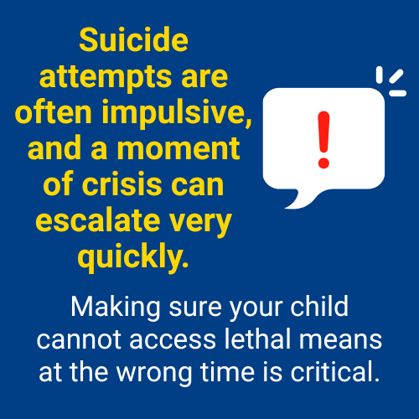
According to Virginia Code § 18.2-56.2, the legal requirements for parents regarding safe storage of firearms are as follows:
It is unlawful to leave a loaded, unsecured firearm in a manner that endangers the life or limb of any child under the age of 14. Violating this law is a Class 1 misdemeanor.
It is unlawful to knowingly allow a child under the age of 12 to use a firearm unless the child is under the supervision of an adult. For this law, “adult” means a parent, guardian, person standing in loco parentis, or a person 21 years or older with the parent or guardian's permission. Violating this provision is also a Class 1 misdemeanor.

Remember:

Monitoring your child doesn’t mean hovering, it means staying engaged, staying present, and showing love through action. Your role as a caregiver is critical and you don’t have to do it alone. If you are unsure what to do, contact your school counselor, pediatrician or a mental health provider, or the 988 Suicide & Crisis Lifeline for immediate guidance.
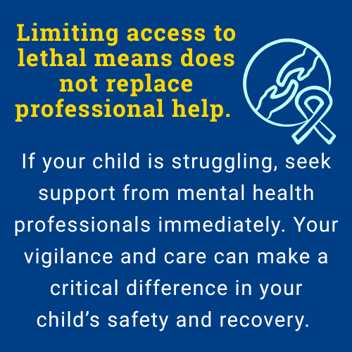


The 988 Suicide & Crisis Lifeline is a free, confidential resource available 24/7 for anyone experiencing a mental health crisis, emotional distress, thoughts of suicide, or substance use concerns. As a parent, you or your child can call, text, or chat 988 at any time to connect with a trained crisis counselor who will listen, offer support without judgment, and help you find local resources if needed. The service is not just for emergencies, it’s also there if you’re worried about your child or someone else and need guidance on how to help. Counselors are specially trained to support people of all ages, and fewer than 2% of calls require emergency services, so you can feel comfortable reaching out for help whenever you need it.

This document is intended as general guidance. Always consult with a licensed mental health professional for advice tailored to your child’s specific needs.

