A Guide for Caregivers: Limiting Access to Knives and Sharp Objects
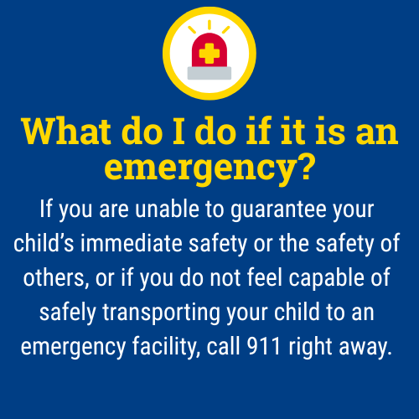
Children and teens experiencing mental health struggles, especially those with thoughts of self-harm or suicide, are at an increased risk of using sharp objects to hurt themselves. Removing or restricting access to these items at home is a vital step in keeping them safe.
Knives and other sharp objects can be used in acts of self-harm, particularly among children and teens experiencing emotional distress. Safe storage of sharp objects is a key component of suicide prevention and youth safety.

What are some common sharp objects to secure or remove?
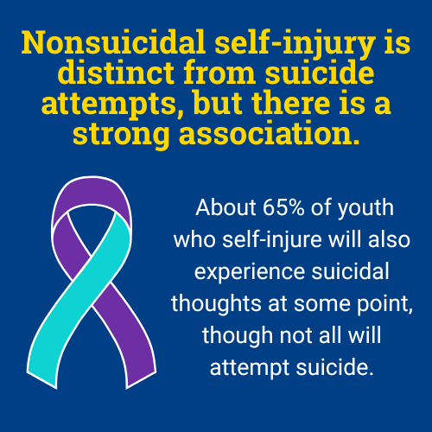
- Kitchen knives (all sizes)
- Scissors and box cutters
- Razor blades and shaving razors
- Pencil sharpeners (blades)
- Utility knives, pocket knives, craft blades
- Broken glass or mirrors
- Nail clippers and files
- Safety pins, needles, and tacks

What steps can I take to protect my child from accessing knives and sharp objects during an emotional crisis?

- Remove or lock up sharp objects. Store all knives, scissors, and razors in a locked drawer, cabinet, or lockbox. Remove unnecessary sharp objects from bedrooms, bathrooms, and other accessible areas.
- Supervise use of sharp items. Only allow access to sharp objects when directly supervised by a trusted adult. Consider alternatives for daily needs (e.g., use electric razors, pre-cut food, or safety scissors).

- Regularly check for hidden items. Periodically check your child’s room, backpack, and common areas for sharp objects that may have been hidden or brought in from outside.
- Communicate openly. Talk with your child about your concerns and the steps you are taking to keep them safe. Encourage them to share their feelings and let them know you are there to support them.
- Inform all caregivers. Ensure that all family members, school staff, and other adults responsible for supervising your child are aware of these safety measures.

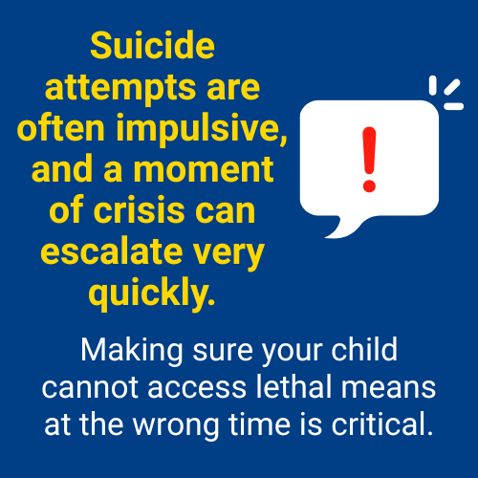

Remember:
Monitoring your child doesn’t mean hovering; it means staying engaged, staying present, and showing love through action. Your role as a caregiver is critical, and you don’t have to do it alone. If your child has expressed suicidal thoughts, made previous attempts, or is currently in emotional crisis, increased supervision and temporary removal of knives and sharp objects from the environment can be lifesaving. Removing or securing knives and sharp tools is not overreacting; it is protecting your child and creating a safe space for healing. If you are ever unsure what to do, contact your school counselor, pediatrician or a mental health provider, or the 988 Suicide & Crisis Lifeline for immediate guidance.

The 988 Suicide & Crisis Lifeline is a free, confidential resource available 24/7 for anyone experiencing a mental health crisis, emotional distress, thoughts of suicide, or substance use concerns. As a parent, you or your child can call, text, or chat 988 at any time to connect with a trained crisis counselor who will listen, offer support without judgment, and help you find local resources if needed. The service is not just for emergencies, it’s also there if you’re worried about your child or someone else and need guidance on how to help. Counselors are specially trained to support people of all ages, and fewer than 2% of calls require emergency services, so you can feel comfortable reaching out for help whenever you need it.

This document is intended as general guidance. Always consult with a licensed mental health professional for advice tailored to your child’s specific needs.

