A Guide for Caregivers: Limiting Access to Ligatures
Ligatures are items that can be used to tie or secure around the neck or body and may be used in attempts of self-harm or suicide.
While these items are everyday objects, they can pose serious risk in moments of crisis or emotional distress. Limiting access to ligatures is a critical part of safety planning for children and teens at risk of self-harm. Many suicide attempts occur during short-term emotional crises and removing or securing ligature risks can reduce the chance of impulsive actions.

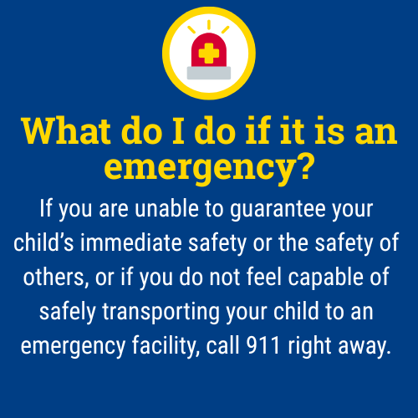

When should I take extra precautions regarding access to ligatures?
- If your child is expressing suicidal thoughts or has a history of self-harm.
- After a recent mental health crisis or hospitalization.
- During periods of increased stress, loss, or significant life changes.

What are common household ligatures?
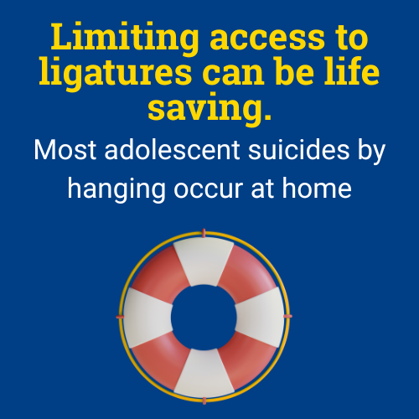
- Belts
- Ties
- Shoelaces
- Cords
- Ropes
- Scarves
- Drawstrings (from hoodies or sweatpants)
- Dog leashes
- Plastic bags

What steps can I take to protect my child from accessing ligatures during an emotional crisis?
- Remove hooks or fixtures that could be used for hanging (especially in bedrooms and bathrooms).
- Store potential ligatures in a locked closet or drawer.
- Remove or shorten cords on blinds or use breakaway cords or cordless blinds when possible.
- Replace drawstrings in clothing with elastic or remove them entirely.
- Talk with other caregivers, babysitters, or relatives about storage expectations in their homes.
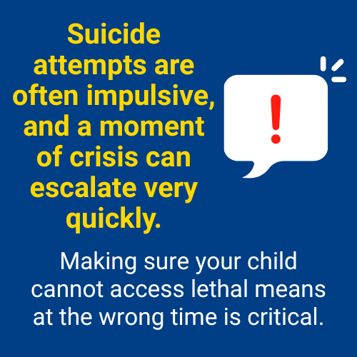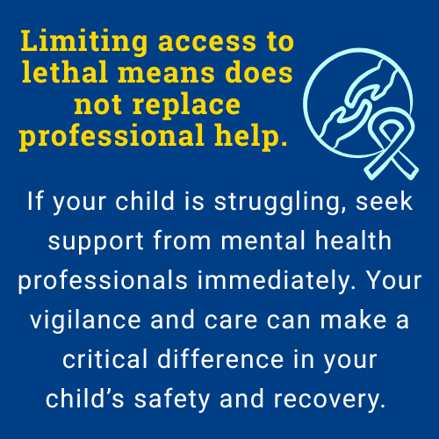

Remember:
Monitoring your child doesn’t mean hovering; it means staying engaged, staying present, and showing love through action. Your role as a caregiver is critical, and you don’t have to do it alone. If your child has expressed suicidal thoughts, made previous attempts, or is currently in emotional crisis, increased supervision and temporary removal of ligatures from the environment can be lifesaving.
If you are ever unsure what to do, contact your school counselor, pediatrician or a mental health provider, or the 988 Suicide & Crisis Lifeline for immediate guidance.

The 988 Suicide & Crisis Lifeline is a free, confidential resource available 24/7 for anyone experiencing a mental health crisis, emotional distress, thoughts of suicide, or substance use concerns. As a parent, you or your child can call, text, or chat 988 at any time to connect with a trained crisis counselor who will listen, offer support without judgment, and help you find local resources if needed. The service is not just for emergencies, it’s also there if you’re worried about your child or someone else and need guidance on how to help. Counselors are specially trained to support people of all ages, and fewer than 2% of calls require emergency services, so you can feel comfortable reaching out for help whenever you need it.

This document is intended as general guidance. Always consult with a licensed mental health professional for advice tailored to your child’s specific needs.

