A Guide for Caregivers: Limiting Access to Medications and Substances
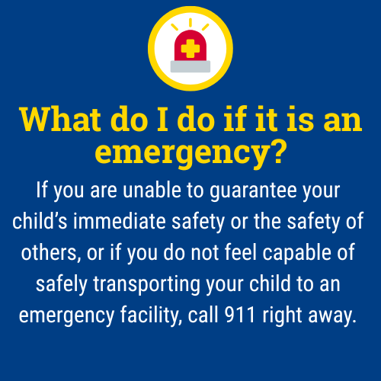
Unintentional overdoses and intentional misuse of medications, alcohol, substances, or illicit substances are serious risks for children and teens. Easy or unrestricted access increases the risk of accidental overdose, misuse, and intentional self-harm.
Safe storage protects kids from accidental ingestion, substance misuse, and self-harm. This guide outlines action steps you can consider to help keep your child safe while maintaining trust and open communication.

What steps can I take to protect my child from accessing medications and substances?

- Store all medications, cannabis products, and alcohol in a locked cabinet or container.
- Avoid keeping medications or edibles in purses, backpacks, or nightstands.
- Visit the Lock and Talk website and scroll to the bottom of the page for the interactive map to find your local Community Services Board (input your zip code) to access free medication lock boxes or free firearm locks.
- Keep only the amount of medication needed for a short period (such as a week or a month) and store the rest securely or ask your pharmacist about safe storage options. Avoid stockpiling medications.
- Keep substances out of sight and out of reach, even items you use regularly.
- Regularly review your medicine cabinet and properly dispose of any expired, unused, or unneeded medications.
- Lock up or remove alcohol, cleaning agents, pesticides, and other toxic substances from accessible areas.
- Talk with other caregivers, babysitters, or relatives about safe storage expectations in their homes.
- Child-resistant does not mean child-proof. Always combine packaging with safe storage.
- Talk to your child about the dangers of medications and substances, and explain why you are taking these precautions.
- Encourage open conversations about mental health and let them know you are there to support them. 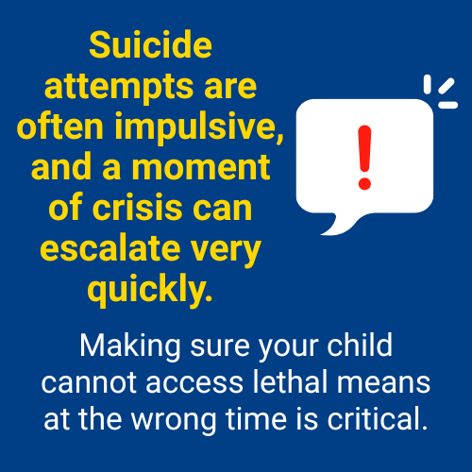

What are some key points to consider regarding access to substances?

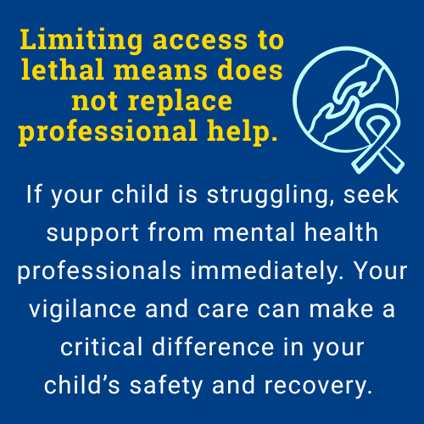
- Even common, everyday medications and substances can be dangerous in large amounts or when misused.
- Opioids and barbiturates are especially lethal in overdose situations, but antidepressants, antihistamines, and even OTC pain relievers can also be deadly.
- Most youth suicide attempts by poisoning involve medications that are easily found at home.
- If you are concerned about your child’s safety, it is important to lock up or remove these items from your home and supervise their use.
- Blister packs make it harder to access large quantities of pills quickly, which can slow down impulsive actions.

What medications and potentially harmful substances may be in my home?
Type of Substance | Common Types
Over-the-Counter (OTC) Medications  These are frequently used in self-poisoning suicide attempts, especially among adolescents, because they are easily accessible and often found in most households. | - Acetaminophen (Tylenol)  - Ibuprofen (Advil, Motrin)  - Aspirin (acetylsalicylic acid)  - Diphenhydramine (Benadryl and other antihistamines)
Prescription Medications  These drugs can be lethal in overdose and are associated with increased risk of suicide attempts and deaths. | - Antidepressants (such as fluoxetine/Prozac, paroxetine/Paxil)  - Anti-anxiety medications (benzodiazepines like temazepam, triazolam, flurazepam)  - Sleep medications (Z-drugs like zolpidem/Ambien, eszopiclone/Lunesta, zaleplon/Sonata, and trazodone)  - Antiepileptic drugs (gabapentin, topiramate, oxcarbazepine, etc.)  - Opioid painkillers (such as oxycodone, hydrocodone, morphine)  - Barbiturates  - Antidiabetic medications
Other Potentially Harmful Substances | - Alcohol (can increase the risk and lethality of overdose when combined with medications)  - Household chemicals (cleaners, pesticides, antifreeze)  - Illicit substances (marijuana, cocaine, heroin, methamphetamine)

What do I do if I believe my child has consumed a harmful substance?
Call 911 or Poison Control at 1-800-222-1222 immediately if you suspect a child has consumed a harmful substance. Keep the item or packaging nearby for reference. Don’t wait for symptoms to appear as quick action saves lives.

Remember:
Monitoring your child doesn’t mean hovering; it means staying engaged, staying present, and showing love through action. Your role as a caregiver is critical, and you don’t have to do it alone. Your home should be a safe space for your child to grow and explore. Limiting access to harmful substances is a simple but powerful way to protect their health, development, and future.
If you are ever unsure what to do, contact your school counselor, pediatrician or a mental health provider, or the 988 Suicide & Crisis Lifeline for immediate guidance.

The 988 Suicide & Crisis Lifeline is a free, confidential resource available 24/7 for anyone experiencing a mental health crisis, emotional distress, thoughts of suicide, or substance use concerns. As a parent, you or your child can call, text, or chat 988 at any time to connect with a trained crisis counselor who will listen, offer support without judgment, and help you find local resources if needed. The service is not just for emergencies, it’s also there if you’re worried about your child or someone else and need guidance on how to help. Counselors are specially trained to support people of all ages, and fewer than 2% of calls require emergency services, so you can feel comfortable reaching out for help whenever you need it.

This document is intended as general guidance. Always consult with a licensed mental health professional for advice tailored to your child’s specific needs.

