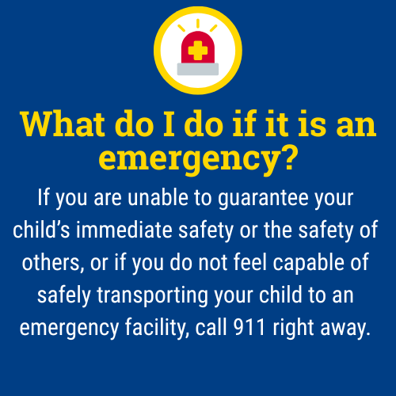

A Guide for Caregivers: Recognizing and Responding to Signs of Self-Harm

This guide outlines general action steps you can consider to help keep your child safe while maintaining trust and open communication. Please note that not all these steps may be necessary depending on your child’s age, symptoms, and other factors that make each situation unique.

What is self-harm?
Self-harm is when someone intentionally hurts themselves as a way to cope with emotional pain, stress, or overwhelming feelings. It can include cutting, scratching, burning, or other actions that cause physical harm.
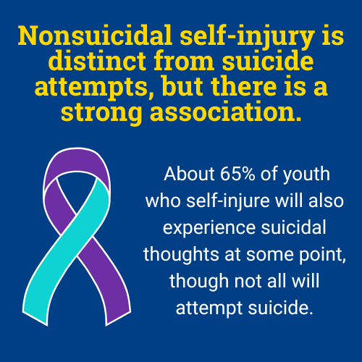

How can I recognize signs of self-harm?
- Unexplained cuts, bruises, or burns
- Wearing long sleeves or pants even in warm weather
- Frequent “accidents” or vague explanations for injuries
- Sharp objects hidden in personal spaces
- Changes in mood, such as sadness, withdrawal, irritability, or hopelessness
- Statements like: “I just want the pain to stop,” or “You wouldn’t understand.”

As a caregiver, how can I respond?
- Stay calm and nonjudgmental: respond with empathy, not anger or panic. Acknowledge their pain without shame.
  - Validate their emotions, even if they seem irrational to you: “That sounds really hard. I’m so glad you shared that with me.”
- Ask open, caring questions:
  - Try: “Can you tell me what’s been going on?”
  - Avoid: “Why would you do that to yourself?”
- Focus on support, not punishment: self-harm is often a coping mechanism, not attention-seeking or rebellion. If your child fears punishment this may result in an increased effort to hide self-harming behaviors.
- Encourage healthy coping strategies such as journaling, art, physical activity, music, or talking to someone they trust.
- Seek professional help: talk to a school counselor, therapist, pediatrician, local community services board, or contact a crisis resource center. Ask about safety plans, coping strategies, and signs of progress or worsening symptoms.

Remember:
Monitoring your child doesn’t mean hovering, it means staying engaged, staying present, and showing love through action. Your role as a caregiver is critical and you don’t have to do it alone.

If you are ever unsure what to do, contact your school counselor, pediatrician, a mental health provider, or the 988 Suicide & Crisis Lifeline for immediate guidance.


The 988 Suicide & Crisis Lifeline is a free, confidential resource available 24/7 for anyone experiencing a mental health crisis, emotional distress, thoughts of suicide, or substance use concerns. As a parent, you or your child can call, text, or chat 988 at any time to connect with a trained crisis counselor who will listen, offer support without judgment, and help you find local resources if needed. The service is not just for emergencies, it’s also there if you’re worried about your child or someone else and need guidance on how to help. Counselors are specially trained to support people of all ages, and fewer than 2% of calls require emergency services, so you can feel comfortable reaching out for help whenever you need it.

This document is intended as general guidance. Always consult with a licensed mental health professional for advice tailored to your child’s specific needs.

