A Guide for Caregivers: Recognizing and Responding to Signs of Violence

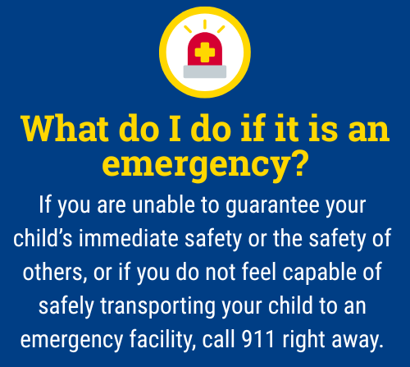
When a child is experiencing thoughts of harming themselves or others, it can be one of the most frightening and overwhelming times for a parent or caregiver. During these critical moments, parents and caregivers provide essential supervision and monitoring of their child, which are powerful opportunities for connection, prevention, and understanding. This guide outlines general action steps you can consider to help keep your child and others safe while maintaining trust and open communication.
Please note that not all of these steps may be necessary depending on your child’s age, symptoms, and other factors that make each situation unique.

What are warning signs I can look for if I am concerned about my student harming others?
If you are concerned that your child may be on a pathway to violence, there are several warning signs and behaviors that indicate it’s important to reach out for additional help:
- Talking, writing, or posting about violence or death, especially targeting specific people, groups, or places (such as schools or public spaces).
- Frequent intense anger, irritability, or daily temper loss.
- Aggressive behavior toward others, including fighting, bullying, or making threats.
- Cruelty to animals or destruction of property.
- Withdrawal from friends, family, or activities that were previously enjoyed.
- Carrying, talking about, or showing an extreme fascination with weapons.
- Making threats or plans to harm others or expressing a desire for revenge.
- Risk-taking behaviors, such as substance use, reckless driving, or unsafe sexual activity.
- Sudden changes in mood, school performance, or social relationships.
- Blaming others for their actions or refusing to take responsibility.
- Preoccupation with violent themes in games, media, or play.
- History of discipline problems or conflicts with authority.
If several of these signs are present, especially if they are new, escalating, or combined, it is crucial for parents to seek help from a qualified mental health professional immediately. Early intervention can help address underlying issues and reduce the risk of violence.

As a caregiver, how can I respond?
- Stay in control: respond to escalating situations with a calm, firm tone (avoid yelling).
- Ask open, nonjudgemental, caring questions, such as: “Can you tell me what’s been going on?”
- Validate their emotions, even if they seem irrational to you: try stating, “That sounds really hard. I’m so glad you shared that with me.” Let them know it's okay to feel angry, but there are better ways to express those feelings. Avoid dismissing, minimizing, or trying to immediately fix things.
- Set clear and consistent boundaries: explain what behaviors are not acceptable and why.
- Focus on support, not punishment: let them know they are not alone, and that you will help them.
- Remove means of harm: firearms, secure medications, sharp objects, or anything that could be used for self-harm or harm to others.
- Encourage healthy coping strategies: journaling, art, physical activity, music, or talking to someone they trust.
- Monitor media exposure: limit access to violent or age-inappropriate media content. Review your child’s social media accounts (Instagram, Snapchat, TikTok, etc.) and internet search history for concerning content, conversations, or posts.
- Model healthy conflict resolution: show your child how to handle frustration and solve problems.
- Seek professional help: talk to a counselor, therapist, pediatrician, or contact crisis resources. Ask about safety plans, coping strategies, and signs of progress or worsening symptoms.

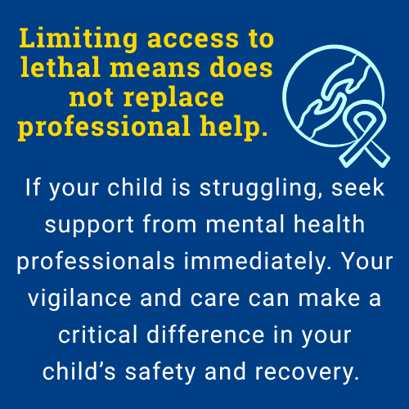

Remember:
Monitoring your child doesn’t mean hovering, it means staying engaged, staying present, and showing love through action. Your role as a caregiver is critical and you don’t have to do it alone. If you are ever unsure what to do, contact your school counselor, pediatrician or a mental health provider, or the 988 Suicide & Crisis Lifeline for immediate guidance.


The 988 Suicide & Crisis Lifeline is a free, confidential resource available 24/7 for anyone experiencing a mental health crisis, emotional distress, thoughts of suicide, or substance use concerns. As a parent, you or your child can call, text, or chat 988 at any time to connect with a trained crisis counselor who will listen, offer support without judgment, and help you find local resources if needed. The service is not just for emergencies, it’s also there if you’re worried about your child or someone else and need guidance on how to help. Counselors are specially trained to support people of all ages, and fewer than 2% of calls require emergency services, so you can feel comfortable reaching out for help whenever you need it.

This document is intended as general guidance. Always consult with a licensed mental health professional for advice tailored to your child’s specific needs.

