A Guide for Caregivers: Recognizing and Responding to Suicide Risk
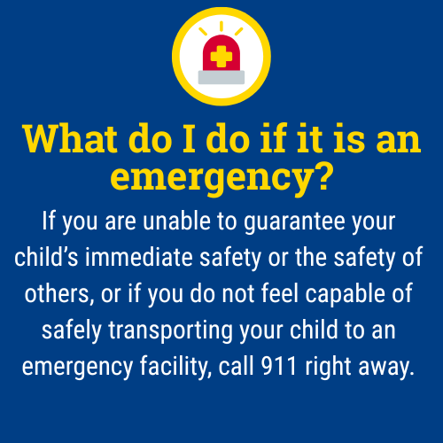
When a child is experiencing thoughts of suicide, it can be one of the most frightening and overwhelming times for a parent or caregiver. During these critical moments, parents and caregivers provide essential supervision and monitoring of their child which are powerful opportunities for connection, prevention, and understanding.

This guide outlines general action steps you can consider to help keep your child safe while maintaining trust and open communication.

Please note that not all of these steps may be necessary depending on your child’s age, symptoms, and other factors that make each situation unique.

What are warning signs I can look for if I am concerned about suicide risk?
- Talking about death or saying things like, “I wish I wasn’t here” or “You’d be better off without me.”
- Drawing or writing about death or dying.
- Sudden withdrawal from family, friends, or favorite activities.
- Aggressive behavior or intense mood swings.
- Increased sadness, hopelessness, or tearfulness.
- Changes in eating or sleeping habits.
- Giving away prized possessions or saying goodbye.

As a caregiver, how can I respond?
- Stay calm and nonjudgmental: take what your child says seriously. Respond with empathy, not anger or panic. Acknowledge their pain without shame.
- Validate their emotions, even if they seem irrational to you: “That sounds really hard. I’m so glad you shared that with me.”
- Avoid dismissing, minimizing, or trying to immediately fix things.
- Ask directly: Use age-appropriate language. For example, “Have you been feeling really sad or thinking about not wanting to be here?” or “I’ve noticed you’ve seemed really down lately. Are you thinking about hurting yourself?”
- Ask open, caring questions:
  - Try: “Can you tell me what’s been going on?”
  - Avoid: “Why would you want to kill yourself?”
- Focus on support, not punishment: let them know they are not alone, and that you will help them get through this.
- Remove or restrict access to means of harm: firearms, medications, harmful substances, sharp objects, ligatures, or anything that could be used for self-harm or a suicide attempt.
- Provide constant, compassionate supervision:
  - Stay physically present with your child as much as possible, especially during the early stages of concern.
  - Keep bedroom doors unlocked or open. If doors have a lock, make sure you can unlock them easily.
  - Limit time alone and possibly consider temporary shared spaces for sleeping arrangements.
  - Inform other trusted adults (e.g., family members, school staff) so they can also offer supervision and support.
  - If your child is in immediate danger, do not leave them alone. Call emergency services (911) or a crisis line for guidance (988).
  - Let your child know that when safety is a concern, privacy may be limited but explain it’s out of care, not punishment. Emphasize that your goal is to keep them safe, not to control or shame them.
  - Review your child’s social media accounts (Instagram, Snapchat, TikTok, etc.) and internet search history for concerning content, conversations, or posts.
- Encourage healthy coping strategies.
- Seek professional help: talk to a counselor, therapist, pediatrician, or contact crisis resources. Ask about safety plans, coping strategies, and signs of progress or worsening symptoms.
- Develop an easy-to-reference safety plan with your child and their school counselor, outlining:
  - Warning signs and triggering or stressful events
  - Coping strategies (including people they can talk to)
  - Actions you will take if things escalate

Remember:
Monitoring your child doesn’t mean hovering, it means staying engaged, staying present, and showing love through action. Your role as a caregiver is critical and you don’t have to do it alone. If you are ever unsure what to do, contact your school counselor, pediatrician, a mental health provider, or the 988 Suicide & Crisis Lifeline for immediate guidance.

The 988 Suicide & Crisis Lifeline is a free, confidential resource available 24/7 for anyone experiencing a mental health crisis, emotional distress, thoughts of suicide, or substance use concerns. As a parent, you or your child can call, text, or chat 988 at any time to connect with a trained crisis counselor who will listen, offer support without judgment, and help you find local resources if needed. The service is not just for emergencies it’s also there if you’re worried about your child or someone else and need guidance on how to help. Counselors are specially trained to support people of all ages, and fewer than 2% of calls require emergency services, so you can feel comfortable reaching out for help whenever you need it.

This document is intended as general guidance. Always consult with a licensed mental health professional for advice tailored to your child’s specific needs.

