Safety Action Steps for Parents and Caregivers: Tools and Strategies for Keeping Your Child Safe

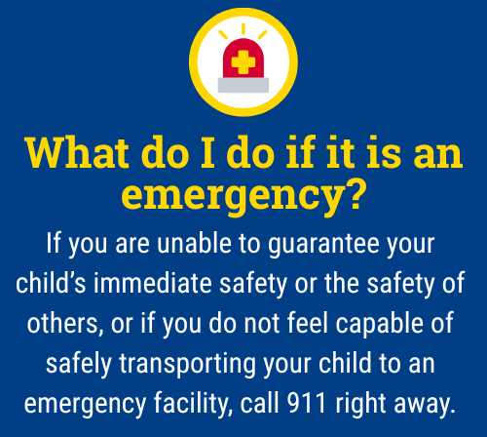
When a child is experiencing thoughts of harming themselves or others, it can be one of the most frightening and overwhelming times for parents and caregivers. During these critical moments, parents and caregivers provide essential supervision and monitoring of their child, which are powerful opportunities for connection, prevention, and understanding.

This guide outlines general action steps you can consider to help keep your child safe while maintaining trust and open communication.

Please note that not all these steps may be necessary depending on your child’s age, symptoms, and other factors that make each situation unique.

1. Provide Constant, Compassionate Supervision
- Stay physically present with your child as much as possible, especially during the early stages of concern.
- Keep bedroom doors unlocked or open. If doors have a lock, make sure you can unlock them easily.
- Limit time alone and possibly consider a temporary sleeping arrangement in a shared space.
- Inform other trusted adults, especially those who may share in supervision of your child throughout their day (e.g., family members, school staff, daycare or after school care staff, athletic coaches) so they can offer support.
- If your child is in immediate danger, do not leave them alone. Call emergency services or a crisis line for guidance.

2. Set Clear Expectations About Privacy and Safety
- Let your child know that when safety is a concern, privacy may be limited but explain it’s out of care, not punishment.
- Emphasize that your goal is to keep them safe, not to control or shame them.

3. Check Social Media and Online Activity
- Review your child’s social media accounts (Instagram, Snapchat, TikTok, etc.) for concerning content, conversations, or posts.
- Monitor your child’s cellphones and school devices. Specifically consider text messages, photos, social media accounts, chat messages (i.e., Google chat, Google Docs) spaces where students can gain access to peers and others can gain access to them.
- Look for themes of hopelessness, isolation, aggression, bullying, or threats, whether your child is expressing or receiving them.
- Consider using parental monitoring tools or apps with your child’s awareness (How to use parental controls to keep your kid safer online).
- Encourage your child to talk about what they see or share online and how it makes them feel.

4. Review Internet Search History
- Check your child’s internet history for searches related to self-harm, suicide, weapons, violence, or other high-risk topics.
- If you find concerning content, respond calmly. Ask questions, show concern, and avoid judgment.
- Use it as a starting point for conversation: “I noticed you searched for [topic]. Can we talk about what’s been going on?”

5. Secure the Environment
- Remove or lock up all potentially dangerous items: medications (both prescription and over-the-counter medications), sharp objects, firearms, alcohol, etc.
- If you own firearms, ensure they are stored unloaded, locked, and separate from ammunition—with no access by your child.
- Store household cleaners, ropes, or other harmful items out of reach.

6. Maintain Open and Ongoing Communication
- Ask your child directly how they are feeling. Use calm, non-judgmental language.
- Check in daily: “On a scale of 1-10, how stressful was your day?” or “Anything on your mind you want to talk about?”
- Validate their emotions, even if they seem irrational to you: “That sounds really hard. I’m so glad you shared that with me.”

7. Collaborate with Mental Health Professionals
- Keep in close contact with school counselors, therapists, counselors, or doctors working with your child.
- Share what you observe at home since they may not see the same behaviors at school or in clinical settings.
- Ask about safety plans, coping strategies, and signs of progress or worsening symptoms.

8. Keep a Written Safety Plan
- Develop a safety plan with your child and their school counselor, outlining:
  - Warning signs
  - Coping strategies
  - Multiple people they can talk to, in multiple settings (school, home, etc.)
  - Actions you will take if things escalate beyond your control or become unsafe
- Keep the plan somewhere visible and easy to reference. Consider sharing it with another family member who may be able to support you and your child.

9. Practice Self-Care and Get Support for Yourself
- Caring for a child in crisis is emotionally demanding. You deserve support, too.
- Talk to a counselor, support group, or trusted friend about your own feelings and stress.
- Taking care of yourself models healthy coping and helps you stay grounded.
- Consider “tagging in” someone you trust who could share in the caretaking and supervision of your child should you become overwhelmed.

Remember:
Monitoring your child doesn’t mean hovering, it means staying engaged, staying present, and showing love through action. Your role as a caregiver is critical and you don’t have to do it alone.
If you are ever unsure what to do, contact your school counselor, pediatrician, a mental health provider, or the 988 Suicide & Crisis Lifeline for immediate guidance.


The 988 Suicide & Crisis Lifeline is a free, confidential resource available 24/7 for anyone experiencing a mental health crisis, emotional distress, thoughts of suicide, or substance use concerns. As a parent, you or your child can call, text, or chat 988 at any time to connect with a trained crisis counselor who will listen, offer support without judgment, and help you find local resources if needed. The service is not just for emergencies, it’s also there if you’re worried about your child or someone else and need guidance on how to help. Counselors are specially trained to support people of all ages, and fewer than 2% of calls require emergency services, so you can feel comfortable reaching out for help whenever you need it.
This document is intended as general guidance. Always consult with a licensed mental health professional for advice tailored to your child’s specific needs.

This document is intended as general guidance. Always consult with a licensed mental health professional for advice tailored to your child’s specific needs.

